CV IVÁN VOZMEDIANO PECES
C/25, 10; Sant Lluis
Islas Baleares
Tlf: +34 637 36 85 86
ivnvoz@gmail.com

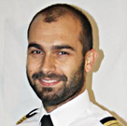
IVÁN VOZMEDIANO PECES

Flight Crew License (H): E.FCL.00056489
Flight Crew License (A): E.FCL.00060546
Passport: PAP053240, Spanish
Birth: 03-12-1981, Cartagena (Murcia), Spain
Address: C/25, Nº 10. Sant Lluis (Islas Baleares)
CP: 07713, Spain
Tel: +34 637 368 586
E-mail:gestoin.aviadoc@gmail.com

EDUCATION

May. 2014 - Oct. 2015 AIRPLANE PILOT, ATPL (A)

ATPL Airplane + CPL (A) + IR (A) + ME (A)

Flyschool - Madrid, Spain
Website: www.flyschool.es
Contact: Rafael López gerencia@flyschool.es

Sept. 2011- Sept. 2013 HELICOPTER PILOT, ATPL (H)
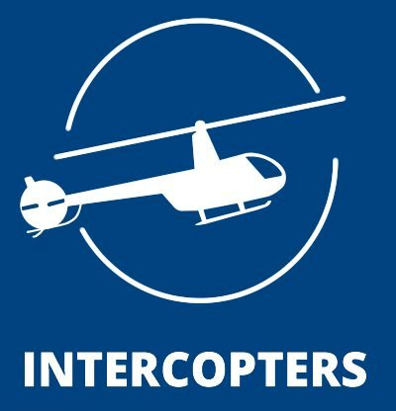
ATPL Helicopter (frozen) + CPL (H) + R22 TR
Intercopters S.L. - Madrid, Spain
Website: www.intercopters.com
Contact: Higinio A. operaciones@intercopters.com

Oct. 1999 - Oct. 2007 AERONAUTICAL ENGINEER MASTER DEGREE
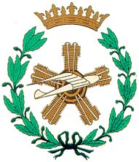
ETSIA UPM, Polytechnic University of Madrid, Spain
Ingeniero Superior Aeronáutico
Website: www.aero.upm.es
Contact: secretario@aerospacial.upm.es

Sept. 2012- Jul. 2013 FLIGHT TESTING MASTER
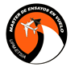
Flight Test and Aircrafts Certification (650 hours)
ETSIA UPM Polytechnic University of Madrid, Spain
Website: www.masterensayosenvuelo.es
Contact: Jesús Ruiz jesus.ruiz@military.airbus.com

PROFESSIONAL EXPERIENCE

Feb. 09 - Actually AVINCIS ESPAÑA

Jun. 20 – Actually
- Beechcraft airplane B200GT EMS MP+IR+PBN PICUS

- Bell 212/412 helicopter Firefighting PICUS
Jul. 15 – Mar. 19
- Standardization Manager.
- Beechcraft airplane B200 EMS MP+IR+PBN Copilot.
- Helicopter AB-212 Spanish Navy MP Glass cockpit, Test Pilot.

Oct. 11 – Sept. 15
- Airworthiness Manager CAMO for Eurocopter Fleet: BO 105, BK 117, SA 365 N1, AS 365 N2/N3, AS 350 and EC-135.
Oct. 09 – Oct. 11
- PART 145 Fleet Engineer.

Feb. 09 – Oct .09 Quality Auditor (Part M, 145 and TRTO)
Albacete/Alicante, Spain.
Website: www.avincis.com
Contact: ruben.garciamedina@avincis.com

Apr. 20 - Actually Flyschool Air Academy
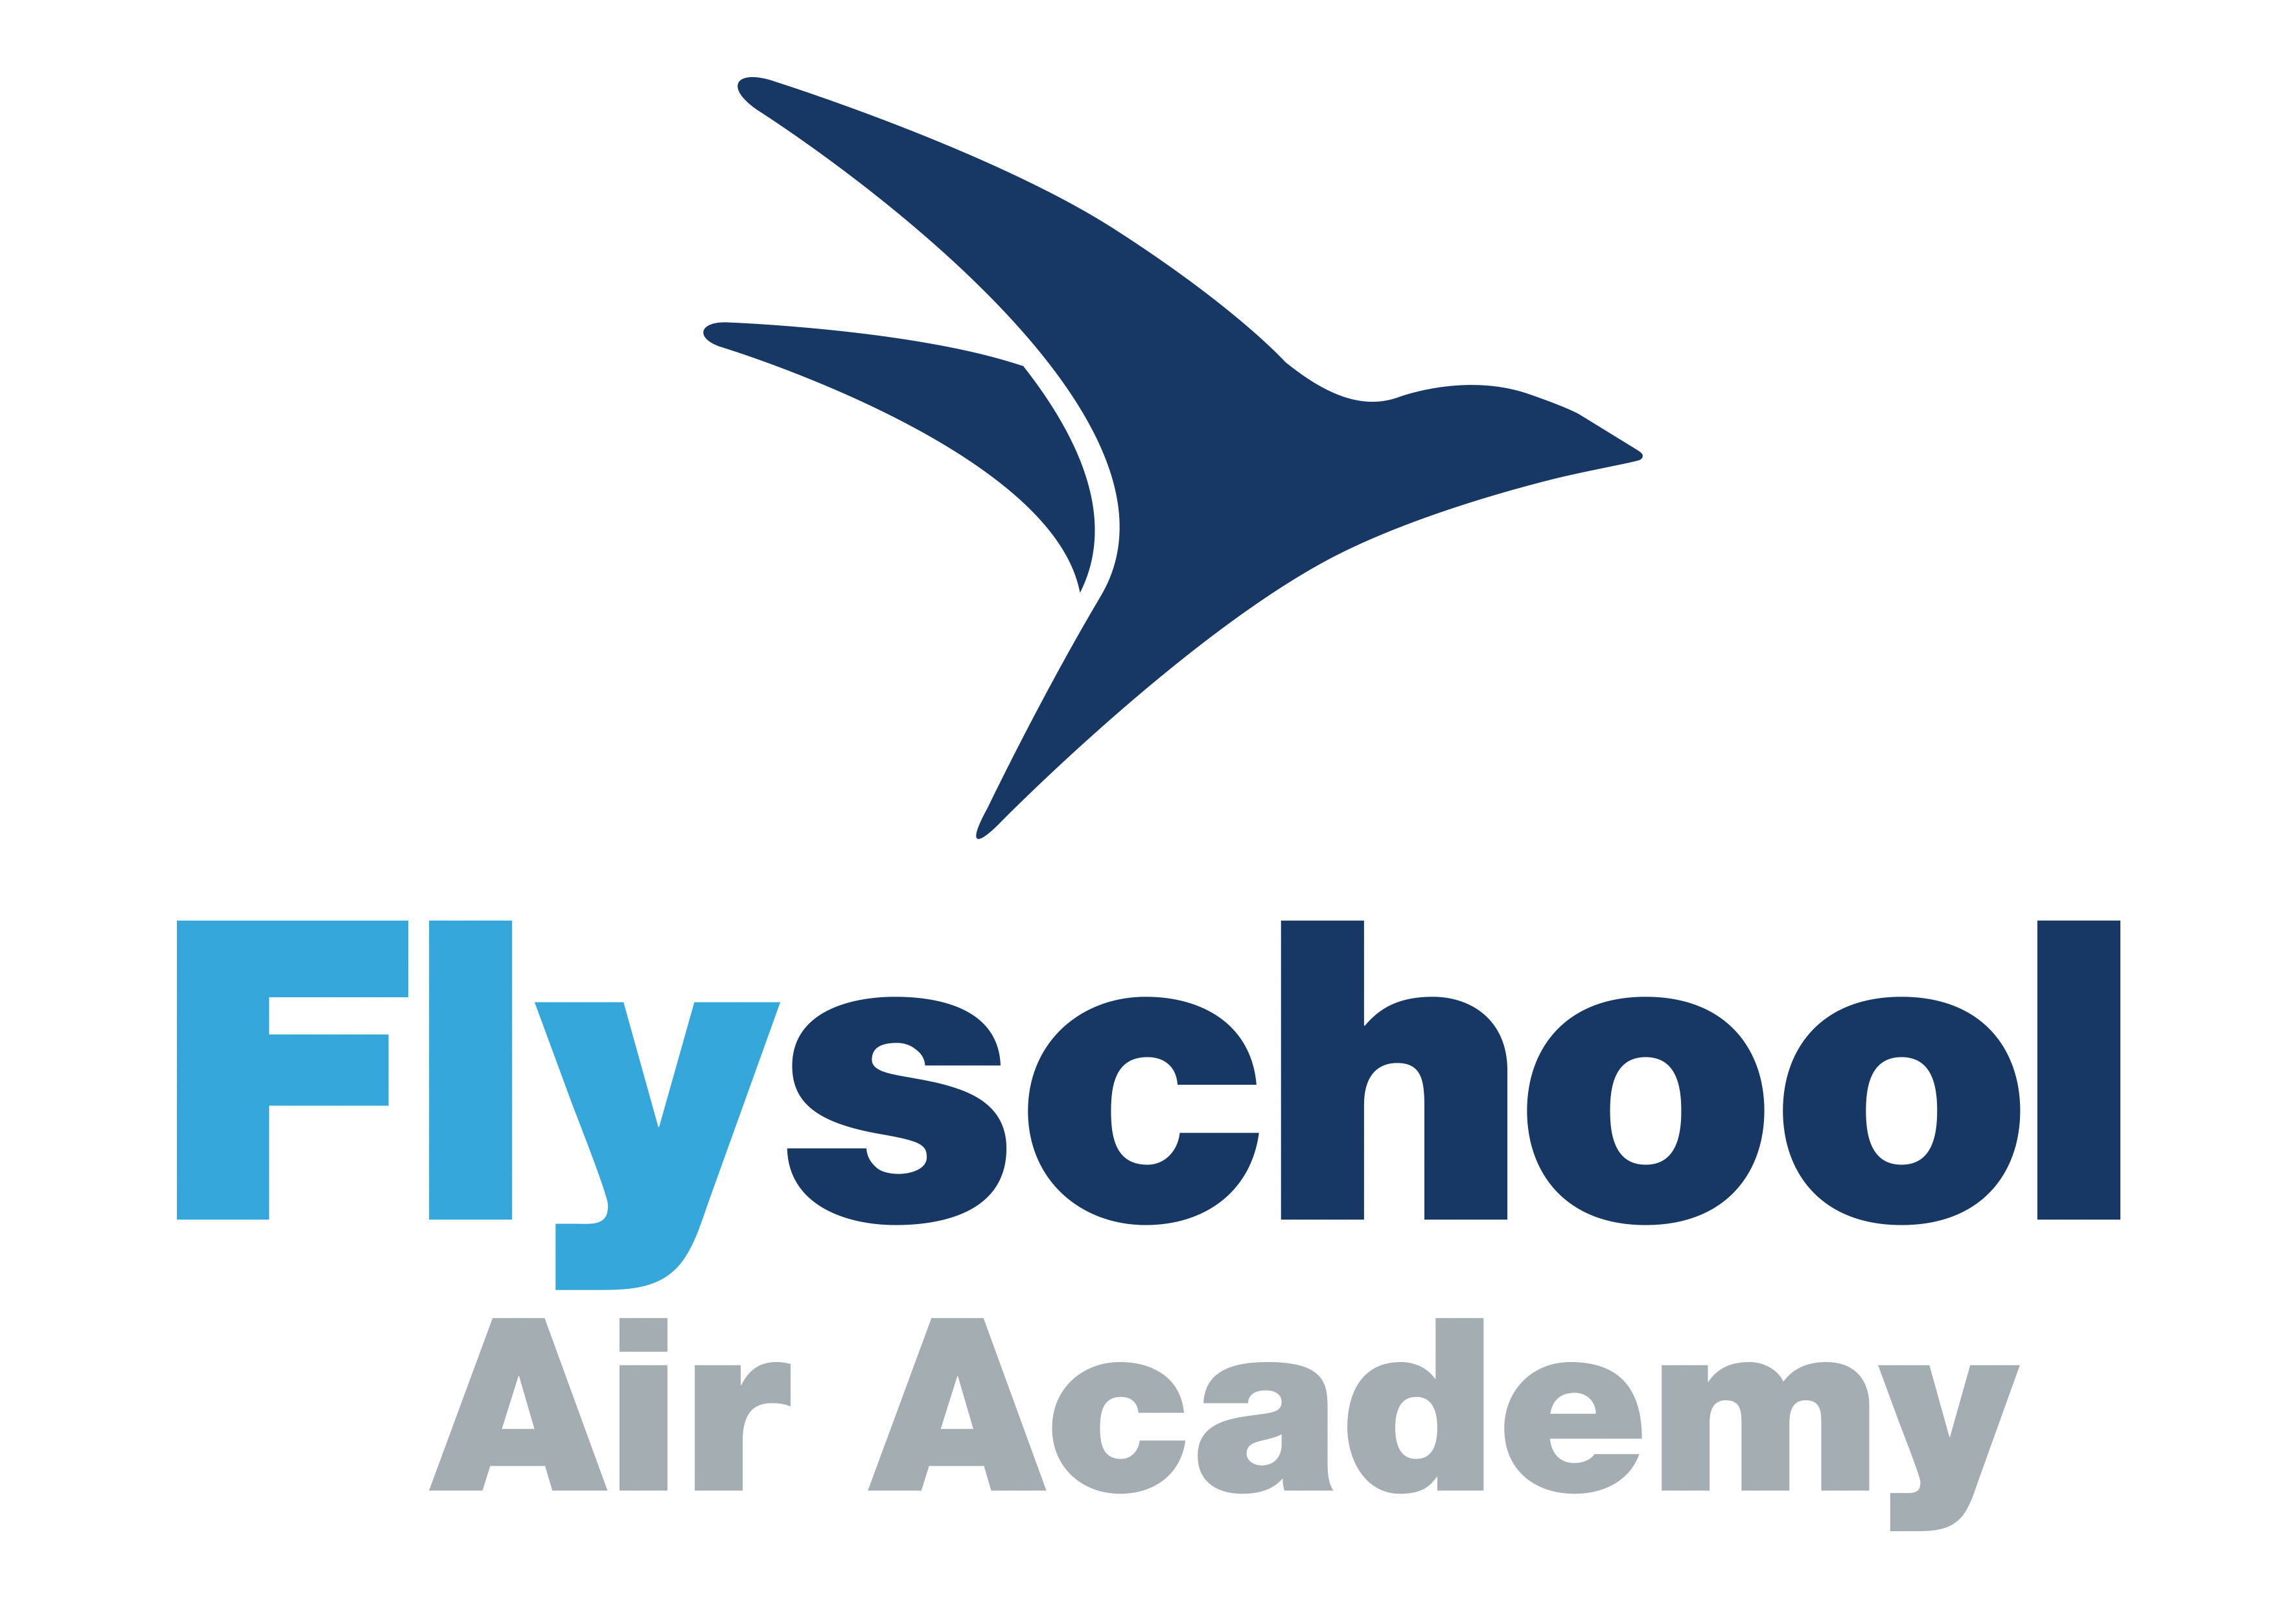
- Safety & Compliance Manager ATO&CAO.
Madrid, Spain.
Website: www.flyschool.es
Contact: gerencia@flyschool.es

Apr. 20 - Actually Aviadoc

- Safety & Compliance Expert.

- Aviation Auditing & Consulting.
Sant LLuis, Spain.
Contact: gestion.aviadoc@gmail.com

May. 19 - May. 20 VUELING AIRLINES S.A.

-First Officer Airbus A319/320/321 MP/IR/PBN
Barcelona, Spain.
Website: www.vueling.com
Contact: oficina.pilotos@vueling.com

Jul. 07 - Oct. 08 FERROVIAL

Terminal 4 Production Manager.

Adolfo Suárez Madrid-Barajas Airport. Madrid, Spain.
Website: www.ferrovial.com
Contact: rgdelacalera@ferrovial.es

Jun. 05 - Sep. 05 ITP (Industria de Turbopropulsores).

Grant at Design Department. Rolls-Royce Trent-900.
San Fernando de Henares (Madrid), Spain.
Website: www.itp.es
Contact: antonio.antoranz@itp.es

FLIGHT EXPERIENCE

AIRPLANE PILOT | FLIGHT HOURS
AIRBUS A319/320/321 | 672:00
KING AIR B200/B200GT (EMS) | 659:00
PIPER PA-34 (Twin piston) | 65:55
CESSNA C-150 (Piston) | 38:40
PIPER PA-28 (Piston) | 205:10
TOTAL HOURS | 1640:00
HELICOPTER PILOT | FLIGHT HOURS
AB 212 (Twin Turbine – Glass cockpit) | 106:00
BELL 212/412 (Twin Turbine) | 381:25
R22 (Piston) | 157:35
R44 (Piston) | 10:00
TOTAL HOURS | 655:00
FLIGHT TESTING MASTER | FLIGHT HOURS
PIPER PA-34 GESTAIR MEEV | 6:00
CESSNA C-172 GESTAIR MEEV | 12:30
R22 INTERCOPTERS MEEV | 1:00
CASA C-212 INTA MEEV | 7:30
Sim AIRBUS A320 GESTAIR MEEV | 2:00
Sim EF-2000 TYPHOON AIRBUS MEEV | 2:00
Sim F16 EMYCSA MEEV | 6:00
SUPER DECATHLON EAP (Real Aeroclub España) MEEV | 1:00
EA-200 EAP (Real Aeroclub España) MEEV | 1:00
SF-28 EAP (Real Aeroclub España) MEEV | 1:00
T-21 EAP (Real Aeroclub España) MEEV | 0:30
MDM FOX EAP (Real Aeroclub España) MEEV | 0:30
DHC-1 CHIPMUNK EAP (Real Aeroclub España) MEEV | 0:30
ASK-13 EAP (Real Aeroclub España) MEEV | 0:30
Sim BOEING B757 SENASA MEEV | 4:00
TOTAL HOURS | 45:30
TOTAL HOURS | 2340:30
TYPE RATINGS
BEECH 90/99/100/200/MP
AIRBUS A320 SERIES
BELL212/412/SP

ADDITIONAL EDUCATION

Aug. 2004 EF-18 Hornet Plane Familiarization (100 hours). Air Force, Base Aérea de Torrejón de Ardoz, Madrid, Spain.

Feb. 2009 Quality Auditor (40 hours). AEC, Madrid, Spain.

May 2009 Aeronautical Maintenance Organizations Part 145 (12 hours). COITAE, Madrid, Spain.

Nov. 2010 T1 Turbomeca Engine ARRIEL 2C Level 1 (40 hours). TURBOMECA, Albacete, Spain.

May 2011 Design Organizations and Aircrafts Certification Part 21 (16 hours). INAER, Albacete, Spain.

Jun. 2011 B1.T1 of EC-135 Helicopter (140 hours). EUROCOPTER, Albacete, Spain.

Nov. 2011 T1 Turbomeca Engine ARRIUS 2B (40 hours). TURBOMECA, Bidart, France.

Dec. 2013 Hipobaric Chamber Training. Hypoxia and Decompression training (6 hours). CIMA, Madrid, Spain.

Mar. 2013 Aircrafts Certification (60 hours). MEEV-ETSIA, Madrid, Spain.

Apr. 2013 Unmanned Aerial Vehicles (UAV´s) (60 hours). MEEV-ETSIA, Madrid, Spain.

Apr. 2014 Flight Training Device (FTD Level 3 MCC) Instructor Course. (25 hours). Aero Simulators, Albacete, Spain.

Nov. 2014 Night Vision Goggles NVIS Green B (12 hours). INAER-SESCAM. Cuenca, Spain.

Apr. 2015 Security & Dangerous Goods Air Transportation (12 hours). INAER, Spain.

May 2015 Bell 212/412 Pilot Type Rating (42 Theory hours + 13 Flying hours). INAER, Spain.

Feb. 2016 MCC (Multi Crew Cooperation) Aeroplane B-200 (40 Theorical +20 Flying hours). FLYSCHOOL, Madrid, Spain.

Jun 2016 King Air 200 Series Pilot Type Rating (42 Theorical + 24 Flying hours). FLIGHTSAFETY, London, UK.

Mar. 2017 Flight Instructor (200 Theorical + 30 Flying hours) FLYSCHOOL, Madrid, Spain.

Mar. 2019 Airbus A320 series Pilot Type Rating (48 hours Ground Training, 36 hours VPT, 36 hours FFS Simulator). GTA. Madrid, Spain.

Oct. 2019 Safety Management System. SMS Air Operators (20 hours). SENASA. Madrid, Spain.

Jan. 2022 Aviation Quality Systems (24 hours). SENASA, Madrid, Spain

Mar. 2022 HUET. Helicopter Underwater Escape Training (12 hours). Salvamento Marítimo, Gijón, Spain.

Abr. 2022 Human factors in Aeronautical Maintenance (12 hours). Babcock, Albacete, Spain.

Feb. 2023 Beechcraft B200 Series Pilot Type Rating + B250 differences (42 Theorical + 24 Flying hours). CAE, Oslo, Norway.

Sep. 2023 FDM Flight Data Monitoring. (35 hours). Cranfield University, United Kingdom.

Mar. 2024 CRM Crew Resources Management (8 hours). Avincis, Valencia, Spain.

Apr. 2024 Continuing Airworthiness – Partes M, ML, CAMO, CAO, T y 26. (14 hours). Aerotecnia, Madrid.

Sep. 2024 Quality system Auditors in the Aeronautical field. (5 hours). SENASA, Madrid.

Sep. 2024 Continuing Airworthiness - Regulation 1321/2014: Part M, ML, CAMO, CAO. (5 hours). SENASA, Madrid.

CONGRESSES CONTRIBUTIONS

Spain Representative Member for “Turbomeca European Council”

May 2010 14 th European Council. Innsbruck, Austria.
Contribution: “Spectometric Oil Analysis Parts ARRIEL 2C”.

Apr. 2011 16 th European Council. Courchevel, France.
Contribution: “Erosion in ARRIUS 2B2 diffusers”

Sep. 2011 17 th European Council. Hamburg, Germany.
Contribution: “Laterite Deposits damages in ARRIEL 1E1”

Mar. 2012 18 th European Council. Rome, Italy.
Contribution: “Intermediate Inspections between Overhauls”

PRIZES AND RECOGNITIONS

Honors Graduated, 1st Rank in promotion. High School “Juan de Távora”.
Puertollano, Spain, 1999.

Bronze medal XII Chemistry Olympic Games.
Almería, Spain, 1999.

Proficiency Card Professional Pilot.
FlightSafety, London UK, 2016, 2017, 2018.

ESA European Space Agency - Astronaut Selection Process – 3rd Phase.
European Space Agency, Cologne Germany, 2022.

LANGUAGES

Spanish ICAO Level 6 - Native

English ICAO Level 5

C1 Certification

COMPUTER SKILLS

Operating Systems Windows.
Office Automation Word, Excel and Power Point.
Design Microstation, Solid Edge, Catia, Autocad.
Maths Software Matlab.
Aerodynamics Software Igloo, Sugar, X-Blade.
Flight Data Monitoring PGS, Lumina, Helisafe.

